Plane and Solid Mensuration

Quarter 1 Week 5 Additional Activity No:3

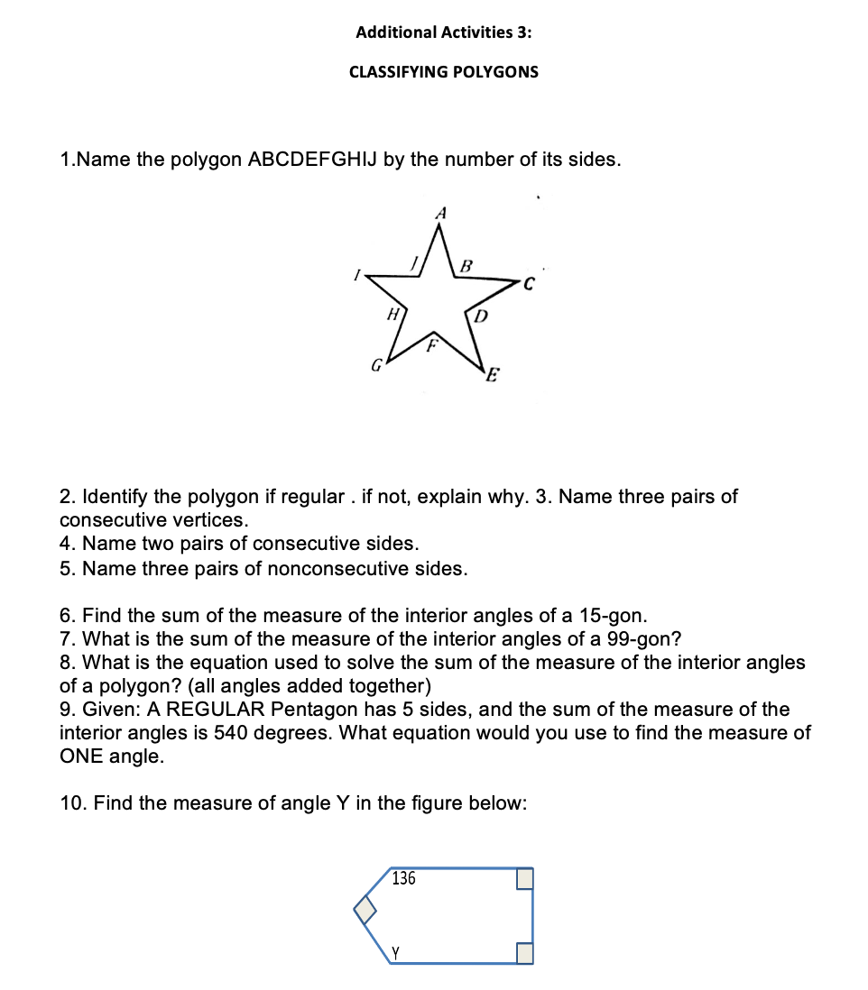Millano, Rei Benedict L. 12-Laplace 9-23-2022

|  |  |
| --- | --- |
| 1. Decagon 2. Inconclusive, though looking at the diagram it may look to be equilateral and equiangular there is no proof or indication of that. Best option is to call it as non-regular decagon 3. Vertices A & B are consecutive as well as Vertices B & C are consecutive and Vertices C & D are consecutive 4. Line segment AB and BC are consecutive and Line segment are BC and CD are consecutive 5. Line segment AB and BC are consecutive and Line segment are BC and CD are consecutive so Line segment AB to BC to CD are consecutive. | 1. where n is the number of sides 2. came from the sum interior formula where n is five. To get one of the interior-angle; simply divide the sum by n (the number of sides) 3. because the following interior angle is given 3 90 $°$ and 136 $°$ and y which all must sum to $540°$ |

Answers

Name/classify the following regular polygon with its corresponding number of sides. Give also the sum of the interior

|  |  |  |  |  |
| --- | --- | --- | --- | --- |
| No of sides | Name | Measure of one Interior Angle | Measure of One Exterior Angle | Sum of Interior Angles |
| 22 | 11. icosidigon | 12. $163.\overline{63}°$ | 13. $16.\overline{36}°$ | 14. $3600°$ |
| 40 | 15. tetracontagon | 16. 171 $°$ | 17. $9°$ | 18. $6840°$ |
| 33 | 19. tritriacontagon | 20. $169°$ | 21. 11 $°$ | 22. $5580°$ |
| 120 | 23. Dodecacontagon | 24. $177°$ | 25. $3°$ | 26. $21240°$ |
| 81 | 27. Octahenagon | 28. 175.56 $°$ | 29. $4.44°$ | 30. $14220°$ |

p